**UNIT-1**

**1.Usability goals and measures**

Usability goals in user interface design are the desired outcomes or objectives that designers aim to achieve to create an effective and user-friendly interface. These goals help guide the design process and ensure that the final product meets the needs of the users. Here are some common usability goals in user interface design, along with associated measures:

1. **Efficiency:** The goal is to make interactions with the user interface efficient and minimize the time and effort required to accomplish tasks.

Measure: Task completion time, number of steps or clicks required to complete tasks, time to locate and access specific features or information.

1. **Effectiveness:** The goal is to ensure that users can successfully achieve their goals and complete tasks accurately and with confidence.

Measure: Task success rate, error rate, accuracy of task completion, user satisfaction with task outcomes.

1. **Learnability:** The goal is to make the interface intuitive and easy for users to understand and learn how to use, especially for new or first-time users.

Measure: Time to learn (time taken for users to become proficient), success rate of completing basic tasks without prior instruction or assistance, user feedback on ease of learning.

1. **Satisfaction:** The goal is to create a positive and satisfying user experience that meets the users' expectations and preferences.

Measure: User satisfaction surveys, user feedback on satisfaction and perceived ease of use, user ratings or reviews.

1. **Error Prevention and Recovery**: The goal is to minimize errors and provide effective error prevention and recovery mechanisms to help users avoid and overcome mistakes.

Measure: Error rate, error types, user success rate in recovering from errors, user feedback on error prevention and recovery features.

1. **Consistency:** The goal is to ensure consistency in design elements, behavior, and terminology throughout the interface, promoting a sense of familiarity and reducing cognitive load.

Measure: Consistency checklist (evaluating consistency in visual design, interaction patterns, and terminology), user feedback on consistency.

1. **Accessibility:** The goal is to make the interface inclusive and accessible to users with disabilities or impairments, ensuring equal access to information and functionalities.

Measure: Compliance with accessibility standards (e.g., WCAG), user feedback on accessibility features and usability for users with disabilities.

1. **User Engagement:** The goal is to create an interface that is engaging and holds the user's attention, promoting active participation and a positive emotional experience.

Measure: User engagement metrics (e.g., time spent, interaction frequency), user feedback on enjoyment, perceived usefulness, and motivational aspects.

These usability goals and measures work together to create a user-centered interface that is efficient, effective, and enjoyable to use. Evaluating these measures during usability testing and gathering feedback from users can help identify areas for improvement and guide iterative design processes.

**Usability goals**

* **Usability goals are the desired outcomes or objectives that organizations aim to achieve when designing and developing interactive systems. These goals revolve around creating user-friendly, efficient, and satisfying experiences for users. Here are some common usability goals:**
* **Learnability: Users should be able to quickly understand how to operate the system and perform tasks without extensive training or documentation. Clear and concise instructions, intuitive interfaces, and consistent design patterns contribute to learnability.**
* **Efficiency: Interactive systems should allow users to accomplish their goals with minimum effort and time. This involves streamlining workflows, providing shortcuts or automation features, and minimizing unnecessary steps or actions.**
* **Memorability: Users should be able to remember how to use the system even after a period of inactivity. Consistent design, well-placed cues, and easy-to-remember interactions contribute to memorability.**
* **Error prevention and recovery: Systems should be designed to minimize the occurrence of errors and provide effective mechanisms for error detection and recovery. This includes providing clear error messages, undo/redo options, and confirming critical actions to prevent irreversible actions.**
* **User satisfaction: The overall user experience should be positive and satisfying. Users should feel comfortable, in control, and confident while using the system**

**Usability Measures**

1. Time to learn

2. Speed of performance

3. Rate of errors by users

4. Retention over time

5. Subjective satisfaction

1.Time to learn. How long does it take for typical members of the user community to learn how to use the actions relevant to a set of tasks

2. Speed of performance. How long does it take to carry out the benchmark tasks

3. Rate of errors by users. How many and what kinds of errors do people make in carrying out the benchmark tasks? Although time to make and correct errors might be incorporated into the speed of performance, error handling is such a critical component of interface usage that it deserves extensive study.

4. Retention over time. How well do users maintain their knowledge after an hour, a day, or a week? Retention may be linked closely to time to learn, and frequency of use plays an important role.

5. Subjective satisfaction. How much did users like using various aspects of the interface? The answer can be ascertained by interview or by written surveys that

__________________________________________________________________________________

**2.** **Universal usability and why it is important.**

* Diversity of human abilities, backgrounds, motivations, personalities, cultures, and work styles is a challenge for interface designers.
* Understanding of differences between users is vital for participation by broadest set of users. Mobile device use has begun to require for designs that are universal usable. Rethinking interface designs for different situations often results in a better product for all users.
* The rethinking covers considerations for users with disabilities, older adults, young users, etc and discussion for hardware and software diversity
* Variations in physical abilities and physical workplaces
* Diverse cognitive and perceptual abilities
* Personality differences
* Cultural and international diversity
* Users with disabilities
* Older adult users
* Designing for and with children

**Universal Usability**

Diversity of human abilities, backgrounds, motivations, personalities, cultures, and work styles is a challenge for interface designers.

Understanding of differences between users is vital for participation by broadest set of users. Mobile device use has begun to require for designs that are universal usable. Rethinking interface designs for different situations often results in a better product for all users.

The rethinking covers considerations for users with disabilities, older adults, young users, etc and discussion for hardware and software diversity

1. Variations in physical abilities and physical workplaces
2. Diverse cognitive and perceptual abilities
3. Personality differences
4. Cultural and international diversity
5. Users with disabilities
6. Older adult users
7. Designing for and with children
8. Accommodating Hardware and Software Diversity

1. Variations in physical abilities and physical workplaces:

Designing for diverse human physical abilities, such as motor skills and ergonomics, is a challenge for interface designers. Research in **anthropometry** provides data on human body dimensions across different populations (age, gender, size). This helps in designing interfaces like cellphone keypads, which can accommodate various hand sizes.

Ergonomics standards like the **Human Factors Engineering of Computer Workstations** outline considerations for adjustable chairs, work surfaces, posture support, and more, ensuring comfort and accessibility. Additionally, mobile device use in dynamic environments (walking, driving, public spaces) requires adaptable designs for varying conditions like lighting, noise, and movement.

The Human Factors Engineering of Computer Workstations standard (HFES, 2007) lists these concerns:

• Worktable and display-support height

• Clearance under work surface for legs

• Work-surface width and depth

• Adjustability of heights and angles for chairs and work surfaces

• Posture—seating depth and angle, backrest height, and lumbar support

• Availability of armrests, footrests, and palm rests

• Use of chair casters

Mobile devices are increasingly being used while walking or driving and in  public spaces, such as restaurants or trains where lighting, noise, movement, and vibration are part of the user experience. Designing for these more fluid environments presents opportunities for design researchers and entrepreneurs

2. Diverse Cognitive and Perceptual Abilities

A vital foundation for interactive-system designers is an understanding of the cognitive and perceptual abilities of the users (Radvansky and Ashcraft, 2013). The journal Ergonomics Abstracts offers this classification of human cognitive processes:

• Short-term and working memory

• Long-term and semantic memory

• Problem solving and reasoning

• Decision making and risk assessment

• Language communication and comprehension

• Search, imagery, and sensory memory

• Learning, skill development, knowledge acquisition, and concept attainment

It also suggests this set of factors affecting perceptual and motor performance:

• Arousal and vigilance

• Fatigue and sleep deprivation

• Perceptual (mental) load

• Knowledge of results and feedback

• Monotony and boredom

• Sensory deprivation

• Nutrition and diet

• Fear, anxiety, mood, and emotion

• Drugs, smoking, and alcohol

• Physiological rhythms

The term intelligence is not included in this list because its nature is controversial and measuring different forms of intelligence is difficult. In any application, background experience and knowledge in the task and interface domains play key roles in learning and performance. Task- or computer skill inventories can be helpful in predicting performance

3.Personality Differences

Users have varied preferences and comfort levels with technology. Some enjoy using devices, while others find them frustrating. Differences in interaction styles, such as preference for graphics vs. text or dense vs. sparse data, highlight the need for flexible design.

While no clear gender-based patterns have emerged, video games show distinct trends, with some games appealing more to women. Additionally, reactions to terms like "KILL" or "ABORT" in software vary, indicating that designers should consider user sensitivities.

For example, some users organize emails meticulously, while others rely on search functions. This highlights the need for designs that accommodate multiple interaction styles and preferences.

4.Cultural and International Diversity

Cultural, ethnic, and linguistic backgrounds significantly influence how users interact with interfaces. For example, users raised reading Japanese or Chinese scan screens differently from those who read English or French. Additionally, users from traditional cultures may prefer stable, simple interfaces, while action-oriented cultures may enjoy animated, dynamic designs.

User-interface design concerns for internationalization include the following:

• Characters, numerals, special characters, and diacriticals

• Left-to-right versus right-to-left versus vertical input and reading

• Date and time formats

• Numeric and currency formats

• Weights and measures

• Telephone numbers and addresses

• Names and titles (Mr., Ms., Mme., M., Dr.)

• Social Security, national identification, and passport numbers

• Capitalization and punctuation

• Sorting sequences

• Icons, buttons, and colors

• Pluralization, grammar, and spelling

• Etiquette, policies, tone, formality, and metaphors

Designers face challenges in creating interfaces that work across multiple languages and cultures. To address this, companies conduct usability studies with diverse user groups. International efforts, like the United Nations World Summit on the Information Society, aim to promote the effective global implementation of technology solutions.

5.Users with Disabilities

Designing for accessibility is crucial to make technology usable for everyone, especially people with disabilities.  
**Assistive Technologies**: Blind users benefit from screen readers (like JAWS or VoiceOver), low-vision users use magnification, and users with motor impairments rely on speech recognition or eye-tracking. Accessible content also helps in everyday situations—like using captions in noisy environments.  
**Standards**: Accessibility standards like the Web Content Accessibility Guidelines (WCAG) ensure inclusive designs. Global initiatives, such as the United Nations Convention on the Rights of Persons with Disabilities, further promote accessibility for all.

**6. Older Adults**

As people age, their physical and cognitive abilities may decline, but well-designed interfaces can help older adults stay engaged with technology.  
**Design for Aging**: Interfaces should be tailored to their needs, such as larger text, simpler navigation, and better accessibility features. Supporting older adults provides social benefits, allowing them to stay connected, share their experiences, and engage in activities like online health support groups.  
Efforts like AARP’s Older Wiser Wired and similar EU initiatives guide designers to create user-friendly systems for seniors.

**7. Designing for Children**

Children’s interactions with technology are often centered on education and entertainment, but they have different needs based on their age and development stage.  
**Design Considerations**: For younger children, interfaces need to accommodate their developing motor skills, emerging literacy, and short attention spans. Teenagers, on the other hand, are often advanced users who set trends and innovate in their use of communication tools. Designers must balance interactive engagement with safety and privacy concerns, especially in online environments.

**8. Accommodating Hardware and Software Diversity**

Technology evolves rapidly, and designers must account for a wide range of devices and platforms, from older systems to the latest mobile technology.  
**Responsive Design**: Interfaces should adapt to different screen sizes, from small mobile devices to large desktop displays. Designers must ensure that their products work across various operating systems and browsers while also supporting backward compatibility.  
**Internationalization**: Supporting multiple languages and cultures is key to reaching a broader audience. Tools like Cascading Style Sheets (CSS) help in creating responsive designs, while isolating text and selecting appropriate metaphors and colors can accommodate cultural differences.

**3.Norman theory.**

Norman’s analysis provides practical examples and a useful theory. Additional design techniques to reduce errors include the following:

1. Correct actions: Industrial designers recognize that successful products must be safe and must prevent users from dangerously incorrect usage of the products. Airplane engines cannot be put into reverse until the landing gear has touched down, and cars cannot be put into reverse while traveling forward at faster than five miles per hour.

2. Complete sequences: Sometimes an action requires several steps to reach completion. Since users may forget to complete every step of an action, designers may attempt to offer a sequence of steps as a single action.

As another example, users of a text editor can indicate that all section titles are to be centered, set in uppercase letters, and underlined without having to make a series of selections each time they enter a section title. Then if users want to change the title style—for example, to eliminate underlining—a single change will guarantee that all section titles are revised consistently.

Thinking about universal usability also contributes to reducing errors—for example, a design with too many small buttons may cause unacceptably high error rates among older users or others with limited motor control, but enlarging the buttons will benefit all users.

**Norman’s Theory and Practical Application:**

Norman’s theory emphasizes designing products that reduce errors by guiding users toward correct actions and preventing dangerous or incorrect use. This is crucial for creating safe and user-friendly designs. Below are two main techniques:

1. **Correct Actions**: Designers incorporate safety features to prevent users from making critical mistakes. For example, in airplanes, engines cannot be put into reverse until the landing gear touches down, ensuring safe operation. Similarly, in cars, the system prevents shifting into reverse while moving forward at speeds above five miles per hour, reducing the risk of accidents.
2. **Complete Sequences**: Complex tasks are often broken down into a sequence of steps. Since users may forget some steps, designers often bundle actions into a single step to avoid errors. A common example is in text editors, where users can apply formatting to all section titles (centered, uppercase, underlined) in one action. If a change is needed, such as removing underlining, it can be applied consistently with a single change across all titles.

**Example Application:**

An everyday application of Norman’s theory can be seen in **smartphones**. Features like **auto-correct** help reduce typing errors, while the **undo** function allows users to easily reverse their last action, preventing mistakes from becoming permanent.

Another example is **modern cars**, where various safety features prevent users from making critical errors, such as shifting gears incorrectly or forgetting to wear a seatbelt, by integrating system constraints and alerts.

**4.Principles.**

While guidelines are low-level and narrowly focused, principles are more fundamental, widely applicable, and enduring. However, they often require more clarification. For instance, the principle of recognizing user diversity is understood by all designers but needs thoughtful interpretation. A preschooler playing a computer game is vastly different from a legal librarian searching for precedents for hurried lawyers. Likewise, a grandmother sending a text message is far removed from an air-traffic controller. These examples highlight differences in users' background knowledge, frequency of use, goals, and the impact of user errors.

1. **Determine Users' Skill Levels**:  
   All design begins with an understanding of the intended users, reflecting their age, gender, physical and cognitive abilities, education, cultural or ethnic backgrounds, training, motivation, goals, and personality. There are often several communities of users for an interface, so the design effort multiplies. Typical user personas—such as nurses, doctors, storekeepers, or students—can have varying combinations of knowledge and usage patterns. Users from different regions may need special attention. Other variables include location (urban vs. rural), economic profile, disabilities, and attitudes toward technology.

For example, separating users into novice or first-time, knowledgeable intermittent, and expert frequent users might lead to differing design goals:

* + **Novice or first-time users**: True novice users (e.g., bank customers making their first cell phone deposit) are assumed to know little of the task or interface. First-time users may be professionals who know the task but not the interface (e.g., travelers using a rental car’s navigation system). Overcoming their uncertainties with instructions or dialog boxes is key. Restricting vocabulary to familiar terms, limiting actions, and providing feedback helps reduce anxiety and build confidence.
  + **Knowledgeable intermittent users**: These users have stable task concepts but may forget menu structures. An orderly menu and consistent terminology reduce the burden on memory. Protection from danger supports relaxed exploration of features. Context-dependent help fills in missing pieces of task or interface knowledge.
  + **Expert frequent users**: These users are thoroughly familiar with the task and interface. They demand rapid response times, minimal feedback, and shortcuts for efficiency. A multi-layer approach to learning helps users of different skill levels, promoting universal usability.

1. **Identify the Tasks**:  
   After understanding the user profile, designers identify tasks. Although all designers agree tasks must be identified, task analysis is often informal or incomplete. Observing and interviewing users helps understand task frequencies and sequences. Designers make decisions about which tasks to support and avoid cluttering the interface with unnecessary actions. High-level tasks are broken down into middle and atomic tasks, which users execute with single menu selections. Frequent tasks should be easy to access, while rare tasks can be deeper in the menu. Task frequencies shape the menu structure and design.
2. **Choose an Interaction Style**:  
   Designers choose from five primary interaction styles after task analysis: direct manipulation, menu selection, form fill-in, command language, and natural language.
   * **Direct manipulation**: Visual representation of actions simplifies tasks. Users can manipulate familiar objects (e.g., dragging an icon to the trash). Direct manipulation is appealing to novices, easy for intermittent users, and rapid for frequent users.
   * **Menu selection**: Users select from clear choices, making tasks achievable with minimal learning. Menu selection requires careful task analysis to ensure functions are supported conveniently. It is suitable for novices and intermittent users and can be appealing to frequent users if designed efficiently.
   * **Form fill-in**: For data entry, form fill-in is appropriate. Users see related fields and enter data. Understanding labels and data-entry methods is essential, and training may be necessary. This style suits knowledgeable intermittent users but may have high error rates.
   * **Command language**: Expert frequent users benefit from command languages, which allow rapid expression of complex tasks. However, error rates can be high, and training is necessary.
   * **Natural language**: Interfaces increasingly respond to spoken or typed natural-language statements (e.g., Siri). While helpful for familiar phrases, users may experience frustration with novel situations.

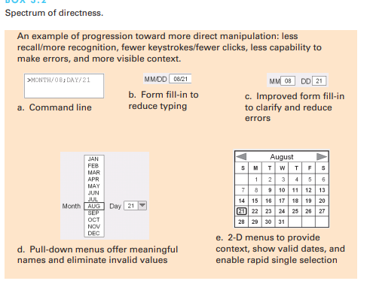

1. **Eight Golden Rules of Interface Design**:  
   These principles, derived from years of experience, guide interface design:
   * Strive for consistency: Consistent sequences, terminology, color, and layout should be maintained throughout the interface.
   * Cater to universal usability: Design for diverse users, offering features for both novices and experts.
   * Offer informative feedback: Provide feedback for every action, varying in magnitude based on the action's importance.
   * Design dialogs to yield closure: Group actions into meaningful sequences with feedback at the end.
   * Prevent errors: Design systems to minimize user errors, and provide constructive instructions for recovery.
   * Permit easy reversal of actions: Actions should be reversible, relieving user anxiety and encouraging exploration.
   * Support internal locus of control: Users should feel in control, with predictable interface responses.
   * Reduce short-term memory load: Keep displays simple and reduce the frequency of required actions.
2. **Prevent Errors**:  
   Error prevention deserves its own focus. Users frequently make mistakes with interactive systems like cell phones or e-commerce websites. Improving error messages can raise success rates and lower future error rates. Superior error messages are specific, positive, and constructive (e.g., "Printer is off, please turn it on"). Designers should aim to prevent errors altogether by creating systems that guide users through actions correctly. For instance, airplane engines cannot be reversed mid-flight, and cars cannot be put into reverse at high speeds.
3. **Ensuring Human Control While Increasing Automation**:  
   As automation increases, human control should remain paramount. Automation reduces errors and user workload for routine tasks, but users must still be able to intervene during unpredictable events. For example, air traffic controllers manage emergencies that cannot be automated. Effective design provides users with sufficient information about the system's status, ensuring they can act appropriately when necessary. Automation should improve system performance without reducing human involvement, and users should be trained to question automation when needed.

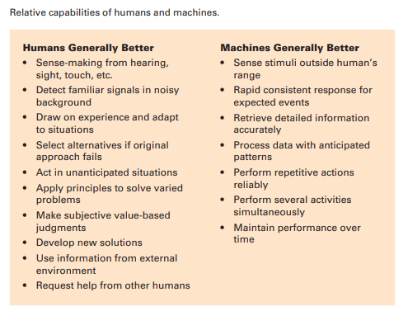

These principles help designers create interfaces that accommodate diverse users, minimize errors, and maintain human control in automated systems.

**5.Guidelines of user interface with examples.**

A guidelines document helps develop a shared design language and promotes consistency in terminology, appearance, and action sequences among designers. It captures best practices drawn from experience and empirical studies. These guidelines stimulate discussions on input formats, hardware devices, and user interactions.

**1. Navigating the Interface:**

Clear navigation rules help users, particularly when tasks involve complex sequences. For instance, the U.S. government’s guidelines for webpage design, such as those from the National Cancer Institute, emphasize usability. A few key rules include:

* **Standardize task sequences**: Users should be able to perform tasks in the same order and manner across similar situations.  
  *Example*: When logging into an account, always provide the same sequence: username input, password input, and then a confirmation button.
* **Ensure links are descriptive**: Links should clearly describe their destinations.  
  *Example*: A link that says "Contact Us" should lead to a contact form, not general information.
* **Use radio buttons for mutually exclusive choices**:  
  *Example*: In a form asking for gender, radio buttons should be used so users can only select one option.
* **Develop pages that print properly**: Ensure the printed version of a webpage is clean and readable.  
  *Example*: Remove navigation bars and sidebars when printing a blog post to focus only on the content.
* **Use thumbnail images to preview larger images**: Display a smaller version of an image that users can click to see the full-sized version.  
  *Example*: An e-commerce website displays thumbnail images of products, which expand when clicked to show more details.

In line with accessibility guidelines, such as those from the W3C, designers should also ensure that content is easy to distinguish:

* **Text alternatives for non-text content**:  
  *Example*: Providing descriptive text for images on a webpage so screen readers can convey the image content to visually impaired users.
* **Color and contrast**: Use strong color contrast for readability, and never use color alone to convey information.  
  *Example*: Mark required fields in a form with both an asterisk and bold text, not just red color.

**2. Organizing the Display:**

Effective display organization is essential for presenting data clearly. Smith and Mosier's guidelines (1986) highlight the following:

* **Consistency of data display**: Terminology, abbreviations, formats, and colors should be standardized.  
  *Example*: All dates should follow the same format (e.g., MM/DD/YYYY) across an application to avoid confusion.
* **Efficient information assimilation by the user**: The format should be familiar and task-related.  
  *Example*: In a sales report, numbers should be right-aligned with consistent decimal points, while labels should be left-aligned to enhance readability.
* **Minimal memory load on the user**: Users should not need to remember information between screens.  
  *Example*: In an e-commerce checkout process, the user’s shipping address should automatically populate the billing address fields unless otherwise specified.
* **Compatibility of data display with data entry**: Displayed information should reflect the format users need to enter data.  
  *Example*: If users must input a phone number with dashes (e.g., 123-456-7890), the display format should reflect that.
* **Flexibility for user control of data display**: Allow users to customize how data is shown.  
  *Example*: A spreadsheet program enables users to sort data by different columns (e.g., date or name) or filter the display to show only specific data.

**3. Getting the User’s Attention:**

When vital or time-sensitive information must stand out, several techniques can be used:

* **Intensity**: Use two levels of intensity, with high intensity for critical information.  
  *Example*: Flashing red text for urgent alerts like “Low Battery” draws immediate attention.
* **Marking**: Use underlining, boxes, or arrows to emphasize important items.  
  *Example*: Highlight the current step in an online multi-step form with an arrow or colored box to guide users.
* **Size**: Larger fonts or objects draw more attention.  
  *Example*: Use larger font sizes for section headings and smaller text for details within the body.
* **Choice of fonts**: Limit the number of fonts for clarity.  
  *Example*: A news website uses a serif font for headlines and a sans-serif font for body text to maintain readability and visual hierarchy.
* **Blinking**: Use sparingly for critical notifications.  
  *Example*: A blinking "New Message" notification alerts users to unread emails but should stop after a few seconds to avoid distraction.
* **Color**: Different colors can signal various levels of urgency or information types.  
  *Example*: Use green for success messages (e.g., “Your payment was successful”) and red for errors (e.g., “Invalid credit card number”).
* **Audio**: Use sound for feedback or alerts.  
  *Example*: A soft “ding” indicates a successful file upload, while a louder “beep” signals a system error.

Different users need different attention strategies. Novices benefit from simple, well-labeled displays, while experts prefer less labeling and rely on layout for understanding. Testing is essential to ensure these techniques are effective for all user groups.

**4. Facilitating Data Entry:**

Data entry is a common source of user errors and frustration. Smith and Mosier’s guidelines offer strategies to ease this process:

* **Consistency of data-entry transactions**: Similar sequences across systems improve learning.  
  *Example*: In an online form, entering the date of birth should follow the same sequence (e.g., MM/DD/YYYY) regardless of context.
* **Minimal input actions by user**: Fewer actions increase productivity and reduce errors.  
  *Example*: Use drop-down lists for state selections to prevent users from typing in the wrong format, reducing errors.
* **Minimal memory load on users**: Users should not have to remember codes or lengthy details.  
  *Example*: When a user selects a shipping address, the system should automatically populate it into the billing address field if it's the same.
* **Compatibility of data entry with data display**: Data entry fields should match the display format.  
  *Example*: When users enter phone numbers or credit card details, display formatting (e.g., spaces or dashes) should match how the user needs to input the data.
* **Flexibility for user control of data entry**: Allow experienced users more control over input sequence.  
  *Example*: In a clothing purchase form, let users choose to select the size or color first, depending on their preference.

These guidelines ensure efficient and error-free data entry, improving overall user experience.

**6.Interface and its goals.**

**1. Usability of Interactive Systems:** Usability is a key factor in the success of an interactive system, focusing on how effectively users can interact with a system to accomplish their goals. The user interface (UI) plays a significant role in determining usability. A well-designed UI allows users to interact smoothly with the system, minimizing errors and reducing cognitive load. Key usability goals include:

* **Efficiency:** Users should be able to complete tasks quickly and with minimal effort.
* **Effectiveness:** The interface must allow users to achieve their goals accurately.
* **Learnability:** New users should be able to understand how to use the system with minimal training.
* **Satisfaction:** The interface should provide a positive experience, reducing frustration and enhancing user engagement.

**2. Motivations for Good Interface Design:** The motivations behind good UI design stem from the need to create systems that are easy to use, efficient, and enjoyable. For example, poorly designed screens may lead to mistakes, frustration, and decreased productivity. Good design can increase productivity, lower training costs, and improve employee and customer satisfaction. It can also reduce support costs by minimizing the need for assistance.

**3. Universal Usability:** Universal usability focuses on making the UI accessible to a diverse range of users, including individuals with disabilities, older adults, and those with varying skill levels. For instance, designing a system with adjustable font sizes and voice commands makes it accessible to people with visual or motor impairments. The goal is to create systems that everyone can use effectively, regardless of their abilities or limitations.

**4. Goals for the Profession of UI Design:** The field of UI design seeks to:

* **Influence academic and industrial research:** Develop theories and methodologies for improving UI design.
* **Provide tools and techniques:** Equip developers with tools that facilitate rapid prototyping and consistent interface design.
* **Raise public awareness:** Promote the importance of usability in everyday technologies, from mobile apps to voting systems.

**5. Guidelines, Principles, and Theories:** UI design is guided by:

* **Guidelines:** These are low-level rules focused on good practices. For example, "Ensure that buttons are clearly labeled" is a guideline that enhances usability by reducing ambiguity.
* **Principles:** Middle-level strategies that help designers think critically about design choices. For instance, "Recognize user diversity" ensures that the interface accommodates different user needs.
* **Theories:** High-level frameworks that provide a conceptual basis for understanding human interaction with systems, such as the "stages-of-action" theory, which outlines how users form goals, intentions, and actions while interacting with an interface.

**6. Defining the User Interface:** The user interface is the part of a system that allows users to interact with it, consisting of input and output mechanisms. Input devices include keyboards, mice, touchscreens, and voice commands, while output devices typically involve screens or audio feedback. The goal of UI design is to create an intuitive interface that allows users to focus on their tasks, not the mechanics of using the system. Proper design minimizes the learning curve and helps users achieve their objectives efficiently.

By understanding these aspects, designers can create systems that meet the diverse needs of users, ensuring a high level of usability and engagement.

**UNIT-2**

**1.Direct manipulation with an example.**

**Direct manipulation** refers to an interactive design style where users directly engage with on-screen objects and actions, often using visual metaphors. It’s a user-friendly method that relies on physical actions (like clicking or dragging) rather than typing commands. The concept of direct manipulation has been around for a long time, even before computers, and became popular in computing environments, especially in the early days of the **Xerox PARC** and through Shneiderman's (1983) work.

**Key Example: Driving a Car**

One simple example of direct manipulation is **driving a car**. The driver directly sees the road through the windshield and performs actions such as turning the wheel or braking. The response to these actions is immediate and provides continuous feedback. In contrast, controlling a car using typed commands or a menu system (e.g., “turn left 30 degrees”) would be extremely inefficient and awkward. This real-world analogy shows how direct manipulation works smoothly by providing continuous feedback and control.

**Principles of Direct Manipulation**

Direct manipulation interfaces follow three core principles:

1. **Continuous representation of objects and actions**: Users see objects of interest and interact with them visually, such as icons on a desktop.
2. **Physical actions rather than complex commands**: Users perform actions by clicking, dragging, or tapping on interface objects instead of typing commands.
3. **Immediate feedback**: Actions are rapid, incremental, and reversible, with immediate visual feedback.

**Advantages of Direct Manipulation**

* **Novice-Friendly**: Basic functionalities can be learned quickly, often by observing more experienced users.
* **Fast for Experts**: Experts can perform tasks quickly and even define new functions and features.
* **Error Minimization**: Since users can see the immediate result of their actions, errors are less likely, and error messages are rarely needed.
* **Less Anxiety**: The interface feels comprehensible, and users feel in control because actions can be easily reversed.
* **Increased Confidence**: Users gain a sense of mastery as they are the initiators of actions, and they can predict the system's responses.

**Examples of Direct Manipulation**

1. **Geographical Systems (GPS)**: Systems like **Google Maps** or **Garmin** allow users to directly interact with maps, dragging to reposition, zooming in or out, and viewing routes in real time.

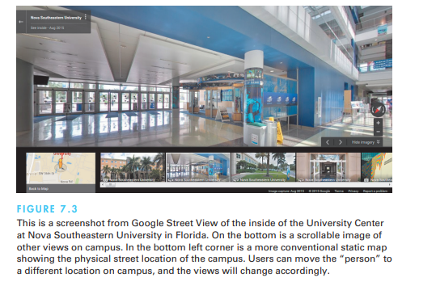

1. **Video Games**: Games like **Pong** (1972) are early examples of direct manipulation, where users rotated a knob to control a paddle on-screen. Modern consoles like the **Nintendo Wii**, **PlayStation**, and **Xbox** have evolved this into much more immersive, physical interactions.

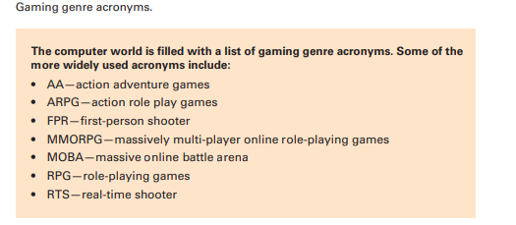

1. **Computer-Aided Design (CAD)**: In design and fabrication software, users can manipulate objects on-screen (rotate, zoom, adjust) using a mouse or touch interface to directly edit their designs.
2. **Direct-Manipulation Programming**: Certain tasks, such as programming a robotic arm or setting preferences in a car (e.g., seat position and mirror settings), can be done using direct manipulation. The user adjusts the controls, and the system repeats these actions automatically.

**Translational Distances in Direct Manipulation**

The effectiveness of direct manipulation depends on the **translational distance**—the gap between the user's physical actions and the resulting effects on-screen. This can range from weak to immersive:

* **Weak Direct Manipulation**: Involves input devices like a mouse or joystick, where the user’s actions are translated into virtual actions.
  + *Example*: Early video game controllers.
* **Medium Direct Manipulation**: The translational distance is reduced, and users interact more directly with on-screen objects.
  + *Example*: Touchscreens, where users physically touch, move, or pinch objects on the screen.
* **Strong Direct Manipulation**: Involves more immersive interactions, such as gesture recognition or manipulating objects in virtual reality.
  + *Example*: **Virtual reality systems** like the **Oculus Rift**, where users interact with a virtual environment using body movements.
* 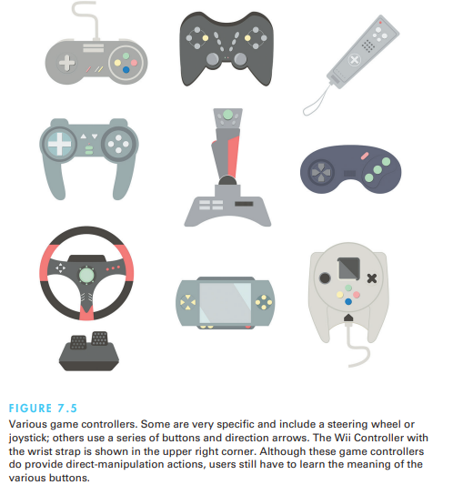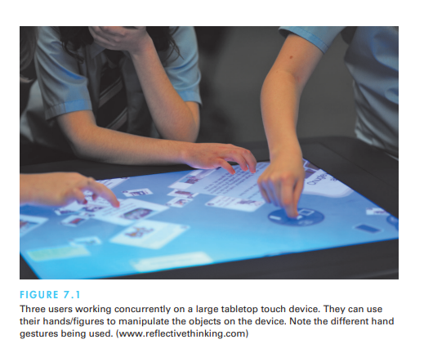
* 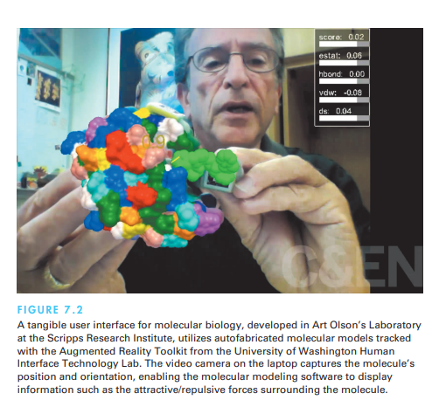

**Disadvantages of Direct Manipulation**

* **Complex to Code**: Implementing direct manipulation can require sophisticated programming.
* **Resource Intensive**: Direct manipulation interfaces can consume a lot of system resources.
* **Requires Screen Space**: Direct manipulation often demands more screen space, which can be limiting on smaller devices.
* **Slower for Some Tasks**: Actions like pointing and clicking can be slower than typing, especially for users who are fast with a keyboard.
* **Accessibility Issues**: Users with visual impairments or motor difficulties may struggle with interfaces that rely heavily on visual feedback and fine motor control.

**2.Organizational support for design.**

Organizational support for design in digital interaction is key to creating successful products and services. When a company prioritizes design, it leads to better user experiences, customer satisfaction, and overall business success. Here are the main elements:

1. **Design Leadership**: Having executives who value design ensures that it's included in key decisions. These leaders champion design initiatives and allocate resources effectively.
2. **Skilled Design Team**: Employing experienced designers in various fields like UX, graphic, and industrial design brings diverse problem-solving approaches.
3. **Cross-Functional Collaboration**: Encouraging design teams to work closely with other departments, like engineering and marketing, helps integrate design throughout the product or service lifecycle.
4. **User-Centric Focus**: Organizations should prioritize understanding customer needs. Regular user feedback and research should inform the design process.
5. **Design Training**: Offering workshops on design thinking helps spread a culture of innovation and teaches employees how design enhances their work.
6. **Design Guidelines**: Clear design standards maintain consistency across products, ensuring a cohesive brand identity.
7. **Investment in Tools**: Providing the latest design software and tools helps teams work efficiently and produce high-quality results.
8. **Recognition of Design Efforts**: Acknowledging and rewarding good design work motivates teams to maintain high standards.
9. **Prototyping and Iteration**: Encouraging iterative design, where prototypes are tested and refined, leads to better final products.
10. **Top-Down Support**: Strong backing from upper management ensures that design initiatives receive the necessary attention and resources.

By focusing on these areas, organizations can create a supportive environment for design, leading to successful outcomes.

**3.Iterative design process for interactive design. & DESIGN PROCESS (both are same)**

* Design is inherently creative and unpredictable, regardless of discipline. In the context of interactive systems, successful designers blend a thorough knowledge of technical feasibility with an uncanny aesthetic sense of what attracts and satisfies users. One way to define design is by its operational characteristics
* Design is a process; it is not a state, and it cannot be adequately represented statically.
* The design process is nonhierarchical; it is neither strictly bottom-up nor strictly top-down.
* The process is radically transformational; it involves the development of partial and interim solutions that may ultimately play no role in the final design.
* Design intrinsically involves the discovery of new goals
* These characterizations of design convey the dynamic nature of the process. An iterative design process based on this operational definition would consist of four distinct phases.
* requirements analysis (Phase 1),
* preliminary and detailed design (Phase 2),
* build and implementation (Phase 3),
* evaluation (Phase 4)

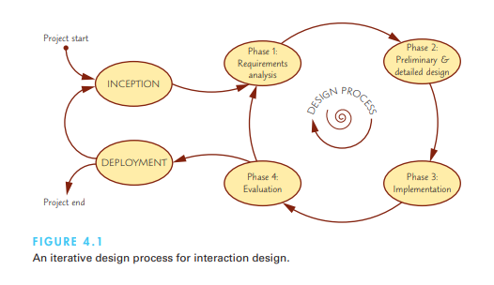

**Requirements analysis**

The **requirements analysis** phase is crucial as it gathers all the necessary information for designing an interactive system. The result is a **requirements specification document**, which includes details about the user community and the tasks they will perform. Requirements typically fall into three categories:

1. **Functional Requirements**: These describe the specific actions or behaviors the system must support. For example, a system may need to allow users to log in, perform searches, or complete transactions.
2. **Non-functional Requirements**: These outline operational aspects like system performance, reliability, and compatibility with hardware and software.
3. **User Experience (UX) Requirements**: These focus on interaction details such as navigation, input methods, and user interface design, specifying how the system should look and feel for the user.

**Phase 2: Preliminary and Detailed Design**

This phase has two main stages:

1. **Preliminary Design (Architectural or Conceptual Design)**: This stage involves creating the system's high-level design. In software engineering, this often means developing a **conceptual map** that illustrates how key components relate to each other.
2. **Detailed Design**: In this stage, specific interaction flows, screen layouts, and other details are planned out. The outcome is a **detailed design document** that specifies how each part of the system will function.

**Phase 3: Build and Implementation**

In the **implementation phase**, the detailed plans are turned into actual code. This phase produces a **working system**, though it may not yet be the final version. The platforms used for development depend on the type of application being created:

1. **Mobile**: Development typically requires using SDKs (Software Development Kits) like Android SDK (Java), iOS SDK (Objective-C), or Windows SDK. These kits often include **emulators** for testing the app on virtual devices.
2. **Web**: Web apps involve client-side development (using JavaScript for browsers) and server-side development (using languages like PHP, Ruby, or JavaScript via Node.js). Web development often focuses on making apps that work across multiple devices.
3. **Personal Computers**: For desktop applications, native SDKs are used depending on the operating system. Tools like Microsoft Visual Basic or C++ are common for creating PC-based software.

**Phase 4: Evaluation**

The final phase is **evaluation**, where the system is tested to ensure it meets the requirements and design specifications. Testing results are documented in a **validation report**. Based on these results, the design team decides whether to proceed with production or make additional improvements, repeating the design cycle if necessary. Validation ensures the system performs as expected and is a critical part of delivering a successful product.

**4. 2D and 3D interfaces.**

Designers often dream of creating interfaces that mimic the richness of 3D reality, believing it will make systems easier to use. However, **3D interfaces** can sometimes make navigation complex and disorienting, with occlusions and unnecessary visual clutter slowing down performance. On the other hand, **2D interfaces** are simpler by design, constraining movement and ensuring clarity. Despite this, there are cases where 3D representations can be highly beneficial, such as in **medical imagery**, **architectural drawing**, **CAD software**, and **scientific simulations**. These industries rely on 3D visuals, but their success often stems from design features that make the interface more intuitive than real-world interactions.

**Features of Effective 3D Interfaces**

To design effective 3D interfaces, here is a checklist of essential features:

1. **Use 3D Techniques Carefully**: Employ occlusion, shadows, and perspective thoughtfully to enhance visibility without causing confusion.
2. **Minimize Navigation Steps**: Simplify the user’s navigation path to reduce the effort needed to complete tasks.
3. **Maintain Readable Text**: Ensure text remains clear by using proper rendering, background contrast, and limiting tilt to 30 degrees or less.
4. **Reduce Visual Clutter**: Avoid unnecessary distractions such as excessive contrast shifts, reflections, or overly complex backgrounds.
5. **Simplify Movement**: Keep user movements simple and intuitive, preferably planar, and avoid surprises like passing through walls.
6. **Prevent Errors**: For specialized tasks, design tools that limit user errors. For example, in surgical simulations, tools should cut only in designated areas.
7. **Facilitate Object Movement**: Support smooth docking and predictable object movements to help users manipulate items easily.
8. **Organize Visuals**: Align groups of objects to make visual searches faster and allow users to recall spatial arrangements easily by placing items in structured layouts.

**Enhancing 3D Interfaces**

Incorporating advanced technologies such as **stereo displays**, **haptic feedback**, and **3D sound** can enhance the experience in some applications. These advanced techniques are likely to be most useful when applied with the following guidelines:

1. **Provide Overviews**: Allow users to see the larger picture with plan views or aggregated data, giving them context.
2. **Allow Teleportation**: Enable rapid context shifts by selecting a destination within an overview, making navigation more efficient.
3. **Offer X-ray Vision**: Let users see through or beyond objects to reveal hidden information or deeper levels of data.
4. **Record History**: Keep a history of actions, allowing users to undo, replay, or edit past interactions.
5. **Enable Rich Actions on Objects**: Let users perform multiple actions on objects, such as saving, copying, annotating, sharing, or sending items.
6. **Support Remote Collaboration**: Provide tools for users to collaborate synchronously or asynchronously within the interface.
7. **Interactive Text**: Allow users to control explanatory text with pop-up or floating labels, and provide more details on demand.
8. **Dynamic Queries**: Allow users to quickly filter out unnecessary information, making data handling more efficient.
9. **Semantic Zooming**: Implement zoom functions where a simple action brings an object into focus and reveals more details.
10. **Use Landmarks**: Make landmarks visible, even from a distance, to aid navigation and orientation.
11. **Multiple Coordinated Views**: Allow users to be in more than one place at a time, viewing data in different ways simultaneously.
12. **Develop Novel 3D Icons**: Create 3D icons that are more recognizable and memorable to users.

**Conclusion**

While 3D interfaces can enrich user experience for specific tasks and industries, 2D interfaces still hold value in simplifying interaction and enhancing productivity. The key to successful 3D design lies in balancing realism with usability, keeping navigation intuitive, and minimizing potential distractions. When 3D elements are necessary, following these guidelines ensures that the interface enhances user interaction without overwhelming them.

**5.AR Vs VR.**

**Augmented Reality (AR)** and **Virtual Reality (VR)** are immersive technologies that blend the real and digital worlds in different ways, providing interactive and enriched experiences for users. While both have unique applications, they share a common goal: to enhance user interaction with environments, whether by overlaying information on the real world or creating entirely simulated environments.

**Virtual Reality (VR)**

**Virtual reality** immerses users in a fully simulated environment, where they can interact with a virtual world that may mimic reality or be entirely fictional. One notable example is **flight simulators**, where pilots are trained using realistic cockpit controls and virtual visuals instead of being in an actual aircraft. The simulation mimics real-world scenarios, providing pilots with visual, auditory, and tactile feedback, such as engine sounds and vibrations, without the risks or costs of real flight.

VR offers users the chance to break free from physical limitations, allowing them to explore new worlds or simulate real-world environments for training and entertainment. This immersive experience has applications beyond aviation, from video games to virtual tourism, and even historical recreations, where users can visit past time periods.

**Augmented Reality (AR)**

**Augmented reality** differs from VR by enhancing the real world with digital information. It allows users to see the actual environment around them while overlaying virtual elements, such as text, images, or 3D models, on top of it. This is highly useful in practical applications. For instance, surgeons can view patient data like sonograms superimposed over a real-time view of the patient, helping them make precise incisions.

AR is also making waves in the retail and interior design industries. Companies like **IKEA** use AR to allow customers to visualize furniture in their homes before making a purchase. A customer can use an app to project a 3D model of a sofa into their living room, giving them a better sense of how it fits and looks in the space. Similarly, an interior designer can use AR tools to instantly change the color of a room or adjust the size of windows during a walkthrough with a client.

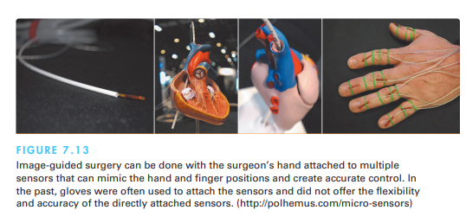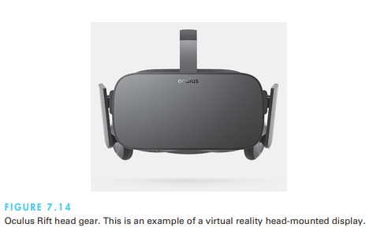

**Key Differences and Applications**

1. **Virtual Reality (VR)**:
   * Immerses users in a completely virtual environment.
   * Common in fields like gaming, training simulators (e.g., flight simulators), and virtual tourism.
   * Breaks the limitations of physical space, allowing users to visit fantasy worlds or replicate real-world environments.
   * Useful for complex skills training (e.g., flying planes or operating machinery) without the associated risks.
2. **Augmented Reality (AR)**:
   * Overlays digital information onto the real world.
   * Practical for fields like medicine, retail, education, and design.
   * Enhances real-world experiences by providing additional context (e.g., showing hidden infrastructure in buildings or visualizing products in real environments).
   * Allows users to interact with both real-world and digital elements simultaneously.

**Conclusion**

Both AR and VR have vast potential in transforming industries and user experiences. **Virtual reality** offers immersive simulations for education, training, and entertainment, transporting users to new worlds or mimicking real-world environments. **Augmented reality**, on the other hand, enriches real-world interactions with digital overlays, providing practical solutions in fields like medicine, design, and retail. As technology continues to advance, both AR and VR are likely to become even more integral in everyday applications, blending the boundaries between the real and virtual worlds.

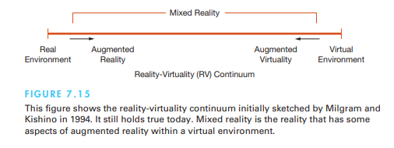

**6.Design process.**

**Already answered.. in 3 q**

**7.Legal issues.**

As user interfaces have become integral to daily life, several **legal issues** have emerged that developers must consider throughout the design, implementation, deployment, and marketing of software. Below are some of the key legal concerns related to user interface design:

1. **Privacy and Security**:
   * **Data Protection**: When systems store sensitive information, such as medical, legal, or financial data, developers must ensure the security of this data to prevent unauthorized access or tampering. Legal regulations like **GDPR** in Europe and **HIPAA** in the United States govern how sensitive data should be handled.
   * **Monitoring and Surveillance**: Systems that monitor user activities must balance functionality with legal restrictions to ensure user privacy is not violated.
2. **Safety and Reliability**:
   * **Critical Systems**: Interfaces for systems in high-stakes environments like aviation, medicine, or military operations require robust design. Faulty or confusing interfaces can lead to life-or-death situations, and designers may be held liable if user errors result in accidents or harm.
   * **Legal Liability**: If a user interface is proven to be unsafe or unreliable, developers, designers, and operators can face lawsuits for improper design or negligence, especially in fields like air traffic control or medical equipment.
3. **Copyright and Patent Protection for Software**:
   * **Intellectual Property**: Developers invest significant resources into creating software, and they rely on **copyright** and **patent protection** to safeguard their work. However, **software piracy** remains a challenge, as users may illegally copy software rather than purchase it.
   * **Legal Actions**: While individual users are rarely targeted for piracy, corporations and institutions like universities may face legal action for allowing widespread unauthorized use of software.
4. **Copyright for Online Content**:
   * **Ownership of Digital Content**: Online resources like music, images, and information raise questions of **copyright**. Users often wonder whether they can save or share digital content without violating copyright laws.
   * **Social Networks**: Who owns the data generated on platforms like social media (e.g., friend lists or shared data)? This remains a complex issue with varying legal interpretations.
5. **Freedom of Speech**:
   * **Rights and Limitations**: The internet has become a platform for public discourse, raising questions about the right to **freedom of speech**. Can users post controversial or offensive content on social media? In countries like the U.S., this may be protected under **First Amendment** rights, but platforms may enforce community standards that limit certain types of speech.
   * **Platform Responsibility**: There is ongoing debate over whether platforms like Facebook or Twitter should monitor and remove offensive content. Legal standards for what is acceptable online differ widely across countries.
6. **Equal Access for Users with Disabilities**:
   * **Accessibility Laws**: Developers must comply with laws requiring equal access for people with disabilities, such as **Section 508** in the U.S. and similar international regulations. This includes making digital content accessible to individuals with visual, auditory, or cognitive impairments.
7. **International Legal Compliance**:
   * **Global Operations**: Companies like **Yahoo!** and **eBay** must comply with laws in every country where they operate. This adds complexity to legal compliance, as different countries have different regulations regarding privacy, censorship, and copyright.

**Conclusion**

Legal issues surrounding user interface design are complex and evolving. Developers must be aware of **data privacy**, **security**, **copyright**, **freedom of speech**, and **accessibility** regulations when designing software. As technology continues to advance, these legal concerns will likely continue to grow, making it crucial for developers to stay informed and compliant with current laws.

**8.Design frame and design tools.**

**1. Design Frameworks**

Design frameworks provide a structured approach to designing interfaces while adapting to specific project needs. Different frameworks allow teams to organize the design process in a way that is suitable for the project’s scope and objectives. Some of the common frameworks include:

* **User-Centered Design (UCD)**:
  + Focuses on understanding the users' needs, wants, and limitations.
  + The key principle is to prioritize user feedback and usability throughout every phase of the design process.
  + **Example**: Designing a mobile banking app by continuously testing with users to ensure it’s intuitive and user-friendly.
* **Participatory Design (PD)**:
  + Involves users directly in the design process to gather accurate information about their tasks and needs.
  + Engages users early, fostering a sense of ownership and acceptance of the final product.
  + **Example**: Involving teachers in the design of educational software to ensure it aligns with their teaching practices.
* **Agile Interaction Design**:
  + Adapts quickly to change by using rapid, iterative cycles.
  + Teams work in sprints, with frequent testing and modifications.
  + **Example**: Regularly updating features in an e-commerce platform based on user feedback during each sprint.

**2. Design Methods**

These methods represent the practical activities designers undertake to create an interface that meets user needs. Some common design methods include:

* **Ideation and Creativity**:
  + Focus on generating a range of possible solutions to a design problem.
  + Convergence occurs when the design team narrows down the solution space to one final solution.
  + **Example**: Brainstorming sessions to create innovative features for a fitness tracking app.

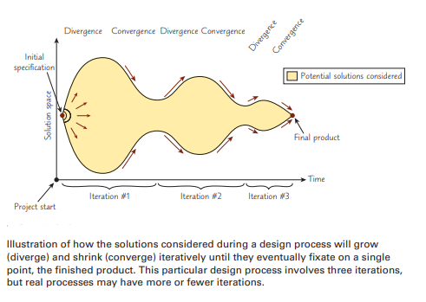

* **Surveys, Interviews, and Focus Groups**:
  + Surveys are a cost-effective way to gather user input, although responses may lack depth.
  + Interviews and focus groups offer more detailed feedback about user preferences.
  + **Example**: Conducting a survey to gather user feedback on the ease of navigation in a new mobile app.
* **Ethnographic Observation**:
  + Designers observe users in their natural environment to better understand their interaction with the product.
  + **Example**: Observing how employees use office software to inform the redesign of an internal dashboard.
* **Scenario Development and Storyboarding**:
  + Helps visualize how users interact with a system through detailed scenarios and storyboards.
  + **Example**: Creating storyboards of how a user might navigate an online shopping platform.
* **Prototyping**:
  + Designers create mockups to simulate how the final product will look and behave.
  + There are varying degrees of fidelity:
    - **Low-fidelity prototypes**: Simple sketches, sticky notes, or paper mockups.
    - **Medium-fidelity prototypes**: Wireframes with basic interaction.
    - **High-fidelity prototypes**: Almost fully functional digital representations with interactive elements.
  + **Example**: Creating a wireframe for a website redesign to test the layout before final development.

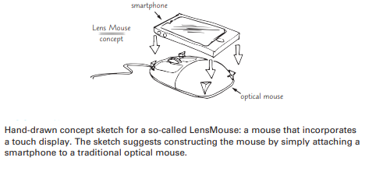

**3. Design Tools**

Design tools enable designers to create prototypes, wireframes, and final interfaces. These tools help streamline the design process, making it easier to translate ideas into functional products.

* **Basic Tools**:
  + Applications like **Microsoft PowerPoint**, **Adobe Illustrator**, and **Photoshop** allow for creating mockups, screen drawings, and visual design.
  + **Example**: Using PowerPoint to create a clickable prototype of a mobile app for initial user testing.
* **Specialized Design Tools**:
  + Tools like **Sketch**, **Figma**, and **InVision** are designed specifically for creating user interfaces and prototypes with actual interactive elements.
  + **Example**: Using Figma to create interactive prototypes of a new website design for collaboration with developers.
* **Graphical User Interface Builders (GUI Builders)**:
  + GUI builders allow designers to drag and drop elements from a library and automatically generate the source code for the interface.
  + **Example**: Using **Xcode** to design and develop the user interface of an iOS app, with the ability to generate code from the graphical design.

**4. Design Patterns**

Design patterns offer reusable solutions to common problems in interface design. These are standardized approaches to solving recurring issues in a way that is both effective and efficient.

* **Example**: A pattern for login screens might involve using a simple form with fields for the username and password, accompanied by a "Forgot password?" link.

**Conclusion**

The design frame and tools a team chooses greatly influence the outcome of the project. Whether it’s through participatory design, user-centered design, or agile methods, the goal remains the same: create user-friendly interfaces that meet the needs of the users. By leveraging the right tools and methods, designers can create engaging, intuitive, and effective user experiences.

**UNIT-3**

**1. Audio menu.**

**Audio Menus in Interactive Voice Response (IVR) Systems**

Audio menus, particularly in Interactive Voice Response (IVR) systems, provide an efficient way for users to interact with services when visual or hands-on interaction is not possible, such as during driving or for vision-impaired users. However, designing effective audio menus presents unique challenges compared to visual interfaces, primarily due to the reliance on memory and auditory feedback. Here’s a guide to key principles and best practices for designing audio menus:

**1. Clear Structure and Organization**

* **Hierarchy**: Organize menu items in a clear hierarchical structure, grouping related options together for better navigation.
* **Naming Conventions**: Use consistent, predictable names for menu items to help users recognize and remember their choices.

**2. Natural Language and Voice Commands**

* **Interaction**: Allow users to navigate the system using natural language or voice commands to make the interface more intuitive.
* **Examples**: Provide sample voice commands to help users understand how to interact with the system.

**3. Limited Menu Depth**

* **Avoid Deep Hierarchies**: Keep the number of menu levels to a minimum, as deep structures can overwhelm users who rely solely on memory.
* **Optimal Choices**: Limit the number of choices to 3-4 options, unless the application requires more, as in the case of movie listings.

**4. Auditory Cues for Navigation**

* **Cues**: Use tones, chimes, or spatial audio to signal transitions between different menu levels or selections, helping users understand the flow of navigation.

**5. Contextual Feedback**

* **Confirmation**: Provide immediate audio feedback to confirm user actions or selections, ensuring users know their input has been registered correctly.

**6. Avoid Information Overload**

* **Manageable Chunks**: Present information in short, manageable audio chunks. Long instructions or multiple options in a single prompt can overwhelm users.

**7. Progressive Disclosure**

* **Layered Information**: Start with high-level options and only reveal more detailed options as the user navigates deeper, similar to a visual menu.

**8. Short and Clear Prompts**

* **Concise Instructions**: Use short, clear prompts to guide users. Avoid complex or lengthy instructions that could confuse or frustrate users.

**9. Hands-Free Interaction**

* **No Physical Input**: One of the main advantages of audio menus is that they allow hands-free interaction, making them suitable for users who are occupied with other tasks, such as driving.

**10. Error Handling and Recovery**

* **Graceful Recovery**: Design the system to handle errors smoothly, such as misinterpreted voice commands. Allow users to repeat commands or offer alternative options.

**11. Testing and Iteration**

* **User Testing**: Conduct thorough testing with diverse user groups, especially those with varying levels of familiarity with audio interfaces.
* **Feedback**: Use insights from user testing to iterate and improve the design.

**12. Personalization and User Profiles**

* **Custom Options**: Allow users to personalize the menu structure or save frequently used options, making the system more efficient for repeat users.

**13. Training and Onboarding**

* **Tutorials**: For systems with advanced features, provide onboarding or tutorial processes to help users understand the available commands and functionality.

**14. Compatibility and Accessibility**

* **Device Compatibility**: Ensure the audio menu works across different devices, such as phones, kiosks, or voice-activated assistants.
* **Accessibility**: Follow accessibility guidelines to accommodate users with disabilities, ensuring equal access for all.

By following these principles, designers can create effective, user-friendly audio menus that are intuitive, reduce cognitive load, and offer a smooth navigation experience, particularly for users who may rely solely on auditory interaction.

**2.Goal of menu selections and the types of menus.**

The goal of menu selections in interface design is to present users with clear, organized options that allow them to make decisions quickly and accurately, facilitating the completion of tasks or navigation within an application. Menus help users locate commands, items, or options without memorizing complex commands, making the interaction more intuitive.

**Types of Menus:**

1. **Binary Menus**: Simple Yes/No or True/False selections that present users with only two options.
2. **Drop-Down Menus**: Commonly used in applications or websites, they show a list of options when clicked, and users select one option from the list.
3. **Pop-Up Menus**: Temporary menus that appear upon a user action (e.g., right-click), providing context-specific options.
4. **Menu Bars**: Horizontal or vertical bars that contain categories (e.g., File, Edit) that expand into more options when selected.
5. **Toolbars and Palettes**: Often found in graphic or word processing applications, toolbars provide quick access to tools or actions with icons that users click.
6. **Radio Button Menus**: Present multiple options but allow the user to select only one at a time.
7. **Checkbox Menus**: Allow users to select multiple items from a list.
8. **Scrolling Menus**: Used for long lists of options, allowing users to scroll through to find the desired item.
9. **Accordion Menus**: Menus that expand and collapse as users select categories, often used in mobile or web interfaces to save space.
10. **Two-Dimensional Mega Menus**: Large menus that provide a broad overview of many options, typically used in e-commerce or content-rich websites.

Each type of menu is designed to cater to different user needs and contexts, improving the efficiency of interaction and navigation within systems.

**DRAW IMAGES FOR EACH IF U KNOW**

**3.** **Dialogue Boxes in HCI Design.**

**Definition**:  
A dialogue box is a pop-up interface element used to interrupt the user's current task to request input, provide information, or present alerts. Dialogue boxes often include a mix of menu selection and form fill-in elements.

**Key Considerations for Designing Dialogue Boxes:**

1. **Clarity and Conciseness**:  
   Ensure that dialogue boxes are easy to understand and brief. The title and message should clearly describe the purpose and expected action.
2. **Consistency**:  
   Maintain uniformity in the appearance, behavior, and structure of dialogue boxes across an application. Consistency in layout, color scheme, and text styles enhances the user experience.
3. **Alignment with User Workflow**:  
   Dialogues should appear naturally in the user's task flow, without interrupting unnecessarily. They should be presented only when required and align with the user's expectations.
4. **Appropriate Timing**:  
   Display dialogues at the right time in the interaction process. Avoid frequent or premature dialogues that can disrupt the user.
5. **Avoiding Overuse**:  
   Use dialogue boxes sparingly to prevent overwhelming or frustrating the user. Reserve them for important interactions, such as confirmations, warnings, or critical input requests.
6. **Clear Call to Action (CTA)**:  
   Dialog boxes should have clearly labeled buttons, such as "OK," "Cancel," or specific actions like "Submit" or "Yes." The buttons should reflect the outcome of each action.
7. **Default Actions**:  
   Where applicable, set a default action (e.g., the "OK" button) that reflects the most likely or common response to speed up user interactions.
8. **Modal vs. Modeless Dialogues**:
   * **Modal Dialogues**: Force users to respond to the dialogue before returning to the main interface, useful for urgent or critical information.
   * **Modeless Dialogues**: Allow users to interact with both the dialogue and the rest of the interface concurrently, ideal for less urgent tasks.
9. **Feedback and Validation**:  
   Provide immediate feedback when interacting with dialogue boxes, such as confirming a user's action or notifying them of errors (e.g., empty required fields or incorrect formats).
10. **Resizable and Scalable**:  
    Dialog boxes should adapt to different screen sizes and allow users to resize them to view more content without compromising usability.
11. **Error Messages**:  
    Use dialogue boxes to display clear and actionable error messages. Ensure that users understand the issue and how to resolve it.
12. **Accessibility**:  
    Design for accessibility by ensuring proper contrast, keyboard navigation, and compatibility with screen readers.
13. **User Testing**:  
    Test dialogue box interactions with a range of users to identify any issues with clarity, timing, or user frustration. Iterate based on feedback to improve the design.
14. **Exit and Dismissal**:  
    Ensure users have an easy way to close or dismiss the dialogue box if they do not wish to take any action. This includes a visible close button or an "Esc" key function.

By adhering to these principles, dialogue boxes can become effective tools in guiding users through tasks without causing frustration or disruption.

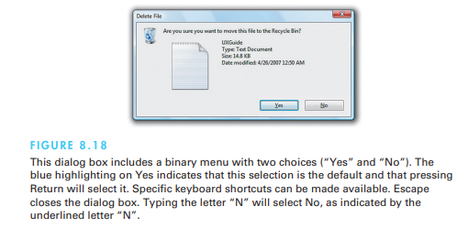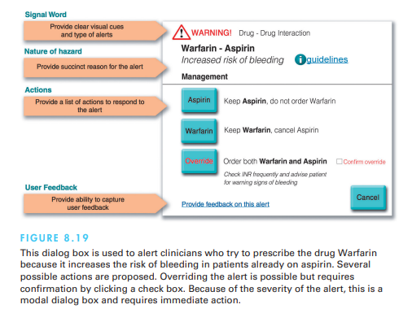

**4.Content organisation small displace.**

Designing for small displays requires a refined approach to content organization to ensure usability and efficiency. Here's an overview of essential considerations for organizing content effectively on small screens:

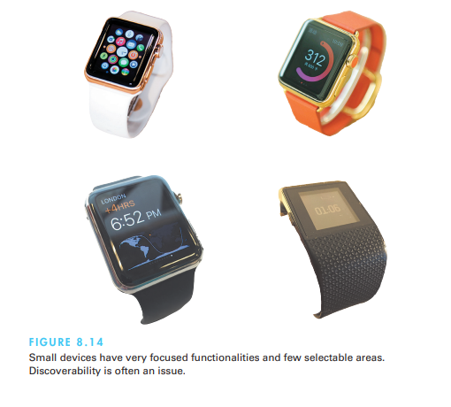

**Key Design Considerations for Small Displays:**

1. **Simplification of Content**:
   * **Less is More**: Prioritize essential content and minimize unnecessary elements to avoid overwhelming users.
   * **Eliminate Data Entry**: Where possible, reduce or eliminate the need for users to input data manually by utilizing features like auto-fill or drop-down menus.
2. **Learnability**:
   * Make interfaces intuitive and easy to learn. Ensure users can quickly grasp the layout and navigation patterns without confusion.
3. **Prioritize High-Frequency Functions**:
   * Consider the frequency of use and importance of functions when determining content layout. The most commonly used features should be easily accessible.
4. **Plan for Interruptions**:
   * Given that users on small displays may experience interruptions, design systems that allow users to easily resume tasks where they left off.
5. **Contextual Information**:
   * Use contextual information (such as location-based services) to display relevant content, minimizing unnecessary navigation steps.
6. **Touch and Gesture Considerations**:
   * **Clear Touch Targets**: Ensure that touch targets are large enough for easy interaction, with enough space between elements to avoid accidental taps.
   * **Gestures**: Incorporate intuitive gestures (swipe, tap, long press) to improve the interaction experience and reduce screen clutter.
7. **Scroll and Swipe-Friendly**:
   * Leave ample room for scroll and swipe gestures to prevent unintended actions. These gestures can help users access additional content without cluttering the interface.
8. **Minimal Navigation Layers**:
   * Avoid deep menu structures, as navigating through multiple layers on small screens can be frustrating. Opt for simpler, flatter structures.
9. **Consistency Across Platforms**:
   * Maintain consistency in navigation, layout, and design elements across different platforms. Users transitioning from a larger screen to a small display should experience familiar interactions.

**Content Organization:**

1. **Content Prioritization**:
   * **Highlight Key Content**: Determine which content is most important and ensure it is displayed prominently. Secondary content can be accessed through additional interactions.
   * **Progressive Disclosure**: Show only essential information at first and allow users to reveal more details as needed. This helps prevent information overload on small screens.
2. **Adaptive Layouts**:
   * **Responsive Design**: Ensure content adjusts fluidly to different screen sizes and orientations, optimizing the layout based on available screen space.
3. **Use of Whitespace**:
   * Use whitespace effectively to separate elements and avoid visual clutter, improving readability and touch target accessibility.
4. **Two-Dimensional Menus**:
   * Where possible, use two-dimensional "mega menus" that allow users to see more options at once, reducing navigation steps.
5. **Deck of Cards Menu**:
   * For extremely small devices, like smartwatches, consider using a "deck of cards" menu where each tap advances to the next item, making it easier to navigate through sequential options.

**Structuring Content on Small Screens:**

1. **Breath vs. Depth**:
   * **Breadth**: Prioritize having fewer levels of navigation to reduce depth. If categories are necessary, organize content into broad categories that users can understand easily.
   * **Depth**: Avoid deep, complex hierarchies. Instead, use a broader menu with fewer layers, making the interface easier to navigate.

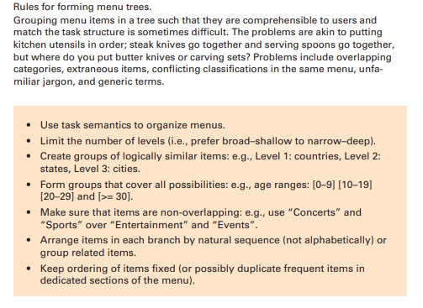

1. **Sequence, Phrasing, and Layout**:
   * **Logical Sequencing**: Order content in a way that makes sense to the user. If items have a natural sequence (e.g., dates or steps), arrange them accordingly.
   * **Clear Phrasing**: Use familiar, concise language that users can quickly understand. Avoid long or ambiguous labels.
   * **Consistent Layout**: Ensure consistency across screens. For example, titles, labels, and error messages should appear in the same location across different pages to create predictability and reduce user anxiety.

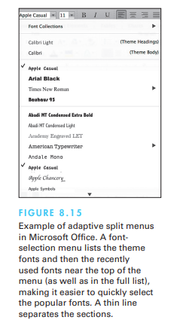

1. **Clear Titles and Labels**:
   * Ensure that titles and labels are clear and descriptive. Use terms that are relevant to the user’s task domain rather than vague or technical labels.



**Conclusion:**

Organizing content on small displays requires prioritization, simplification, and the use of intuitive design patterns. By focusing on reducing complexity, enhancing navigability, and ensuring consistency, designers can create interfaces that provide a smooth user experience despite the limitations of small screens.

Last edited on 17-09-2024 23:46:09 **MR_immortal**